

**Please state Index Number:**

|  |  |  |  |  |
| --- | --- | --- | --- | --- |
| **Student Name:** | | **Rikhsiboev Asadbek** | | |
| **Student Number:** | | **B1902828** | | |
| **Course:** | | **Year 2** | | |
| **Module Code and Title:** | | **(ASB-2320) Current Issues in Economics** | | |
| **Module Leader:** | | **Mr Ng Lai Hock Fabian** | | |
| **Module Tutor:** | | **Mr Ibitoye Olalekan** | | |
| **Assessment:** | | **Individual blog 2** | | |
| **Due Date:** | **09 March 2022** | | **Date Submitted:** | **08 March 2022** |
| **Weighting within Module:** | | **15%** | | |
| **ALL MARKS ARE PROVISIONAL AND ARE SUBJECT TO CHANGE UNTIL CONFIRMED BY THE EXTERNAL EXAM BOARD** | | | | |
| **Comments from Internal Examiner (Name):** | | | | |
| **Strengths:** | | | | |
| **Weaknesses:** | | | | |
| **Areas of Improvement:** | | | | |
| **Provisional Mark out of 100:** | | |  | |
| **ALL MARKS ARE PROVISIONAL AND ARE SUBJECT TO CHANGE UNTIL CONFIRMED BY THE EXTERNAL EXAM BOARD** | | | | |

Table of contents

1. Introduction 2

2. External trading activities of UK after leaving the EU 3

3. FDI and regulation of Brexit to UK 4

4. Brexit’s circumstances on economic well-being of UK 5

5. Several conditions of Brexit to UK’s healthcare and households 7

6. Conclusion 7

7. List of references 8

# Introduction

In reality, when the United Kingdom left the European Union, the word "BREXIT" was coined. In the largest democratic exercise in the United Kingdom's history, the people of the United Kingdom chose to leave the (EU) European Union in a large referendum held in 2016. 2022 (Sandford) Within a judgment by this country's European Court of Justice to quit the EU's common agricultural and fisheries policies, as well as its obligation to contribute vast sums of money to the EU every year, free movement of persons and products was eliminated. The long-term effects of BREXIT on the UK's trading relationship, economy, and households will be explored in this academic report.

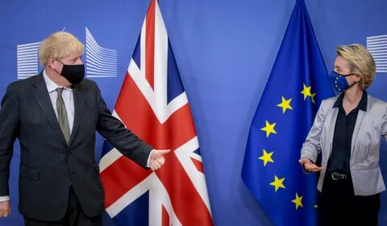

# External trading activities of UK after leaving the EU

Outside of apparent native manufacturing prices, three major factors influence the price of British goods and services for international buyers.

1. For starters, the cost of transporting commodities to and from distant nations may increase the cost of international trade. Products that must be delivered over long distances are usually more expensive than those that can be delivered locally. For example, following Brexit, the trading relationship with Germany, France, and Croatia was revived in new accords, with UK imports amounting to around 16,7% of total imports. 2019 (Thomas Colson; Adam Bienkov)

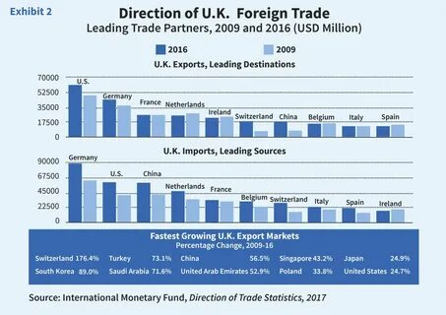

1. Customs charges, which are levied by other countries on the entry of British goods, have the potential to increase the cost of commerce. Prices for British services and products may rise if they are purchased in other countries. There are no import duties to pay on products traveling between EU nations, and there are no customs fees to pay on goods going between EU countries. Non-EU countries, like the European Union, levy customs taxes on products imported from the EU. For example, the United Kingdom established a new economic relationship with the European Union by establishing its own trading rights and regulations. 2021 (Thomas-Bryant)
2. It goes without saying that other non-tariff obstacles might raise the cost of British services and goods purchased overseas, and vice versa. Non-tariff barriers, on the other hand, are defined as "almost any type of trading restriction that is not a true tariff," as the phrase implies. It's possible that some of these roadblocks are the result of policy decisions made by the government. According to 2019 figures, the United Kingdom imported around 29 million euros worth of products from China, India, and Central Asia, indicating an expansion in their unique economic partnership.

# FDI and regulation of Brexit to UK

**Foreign Direct Investment**

When the UK was a member of the EU, it had a multitude of investment opportunities. However, after Brexit, obtaining access to purchase a stock in an overseas firm, investor, or organization became increasingly difficult. According to actual information on the Britannica website, the United Kingdom's total direct investment went only to local company development after Brexit, not to intercontinental states. This has a long-term negative influence on the UK economy and worldwide marketplace. The proportion of foreign direct investment in the UK spent on improving trade with the EU and the rest of the world has risen to over 11 percent, at a cost of 17 million pounds sterling. (2018, Jackson)

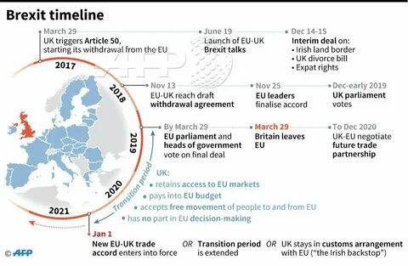

**Regulation**

National policy, clearly, has an impact on a company's ability to make money through the use of labor, capital, and technology. They have an impact on both international and transboundary trade, as we've shown. Some argue that leaving the European Union (EU) would allow the UK to customize legislation to better suit the country's needs, hence boosting financial production.

Other rules, such as rivalry and national aid policies, are aimed at assisting the economy in making more money for people. At the time, ensuring that no firm acquires and then exploits a dominating market position preserved economic productivity and customer well-being. For example, some people, such as John-Vickers, were concerned that a change in the law would make it impossible for the UK to control the foreign market. Because of Brexit, there will be no restrictions on the use of government assistance, allowing the administration to indulge in even more abuses. (2021) (Nelton)

# Brexit’s circumstances on economic well-being of UK

Obviously, when the UK's exit from the EU was causing some negative effects on the country's economy, the EU imposed certain restrictions on the UK's ability to maintain economic relationships with the rest of the world.

- For starters, small enterprises in the UK lost direct trade and business activity with foreign firms, resulting in a loss of authority.

- Second, the Gross Domestic Product (GDP), which had been rising due to exports, fell by more than 7.8%, losing 12 million pounds sterling.

- As a result, according to a Bank of England assessment released on July 22nd, despite the fact that uncertainty had increased "significantly" since the referendum, there had been no signs of a catastrophic economic decline as a result. In the following year, a third of those polled for the report believe that "some negative impact" will be felt. (2020 Lock)

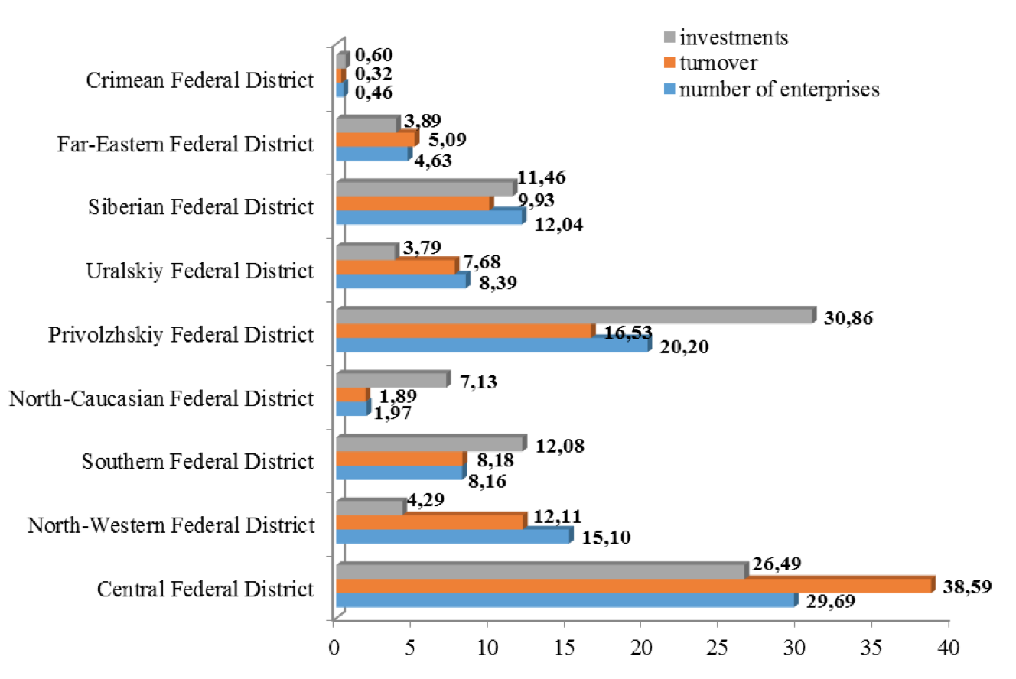

Importantly, if the United Kingdom remained a member of the European Union, the government's estimates that the UK's GDP would grow by 1.6 percent per year in real terms would be halted for the next 15 years. That is how much the UK's GDP would have increased annually if it had stayed in the European Union rather than leaving. It would have increased by 0.4 percent every year if it had done so. In comparison to a remain scenario, a Brexit scenario resulted in a 7.7% drop in the UK's 15-year economic output. It would be 18% higher than it is right now. None of the models predict a reduction in production year over year, as they did in 2009 and previous years. 2016 (Giles)

# Several conditions of Brexit to UK’s healthcare and households

Individuals living in the United Kingdom or an EU Member State who require medical care can receive it for free from the country that provides it. When state pensioners in the United Kingdom or the European Union intend to retire, they should notify the government. Extra health-care measures are included in this protocol, as well as the European Health Information System. sustaining necessary health care, such to that provided by the European Health Insurance Card (EHIC). (2020, Chaplain)

(EHIC)-should, in fact, be set aside. If you're a British national on vacation in an EU Member State, for example, you'll be able to seek the medical care you need. Visitors to the EU on holiday can rest comfortable that their medical requirements will be met while they are there.

# Conclusion

To conclude, "Brexit" is a term that refers to the process via which the United Kingdom exited the European Union in 2016. There has been a severe political schism in the United Kingdom, with the British parliament rejecting a deal, perhaps leading to a Brexit without a separation agreement or a trade agreement. The United Kingdom left for a variety of reasons, including the desire to have its own fiscal regulation over the trading system. Other major causes were the UK's economic production being harmed as a result of EU trade and banking restrictions. That is why the United Kingdom aimed to lower unemployment and crime rates because they were negatively impacting the country's financial households.

# List of references

Chaplain, C., 2020. *EU nationals already living in UK will be protected from NHS fees post-Brexit, Government promises.* [Online]   
Available at: https://inews.co.uk/news/brexit/eu-nationals-rights-uk-nhs-healthcare-brexit-326155  
[Accessed 06 March 2022].

Giles, C., 2016. *Brexit in seven charts - the economic impact.* [Online]   
Available at: https://www.ft.com/content/0260242c-370b-11e6-9a05-82a9b15a8ee7  
[Accessed 06 March 2022].

Jackson, T., 2018. *Exploring foreign investment: where does the UK invest, and who invests in the UK?.* [Online]   
Available at: exploringforeigninvestmentwheredoestheukinvestandwhoinvestsintheuk  
[Accessed 06 March 2022].

Lock, R., 2020. *Will Brexit be beneficial to the UK in the long term?.* [Online]   
Available at: https://www.quora.com/What-will-the-long-term-impact-of-Brexit-be-on-the-UK-economy  
[Accessed 06 March 2022].

Nelton, R., 2021. *GDPR after Brexit & 2021 Update.* [Online]   
Available at: https://www.cookiebot.com/en/gdpr-brexit/  
[Accessed 06 March 2022].

Sandford, A., 2022. *Post-Brexit Guide: Where are we now – and how did we get here?.* [Online]   
Available at: https://www.euronews.com/my-europe/2021/06/23/brexit-draft-deal-first-of-many-hurdles-to-a-smooth-exit  
[Accessed 06 March 2022].

Thomas Colson; Adam Bienkov , 2019. *Here are the answers to every Brexit question you were too afraid to ask..* [Online]   
Available at: https://www.businessinsider.com/what-is-the-brexit-deal-vote-and-what-does-it-mean-2019-1  
[Accessed 06 March 2022].

Thomas-Bryant, K., 2021. *How will Brexit affect businesses? 14 things you need to know.* [Online]   
Available at: https://www.sage.com/en-gb/blog/how-will-brexit-affect-businesses/  
[Accessed 06 March 2022].